Author Declaration Form

This is to certify that I am the author/ co-author of the paper entitled, Aging as a mythological cognitive construction: A case of elderly self-identity in the rural elderly-service stations in Beijing which is being submitted for oral presentation at the 30th AMIC Annual Conference from 24 to 26 September 2024. The material is my own, and where I have quoted or used material from other sources, it has been duly acknowledged together with name(s) of the publication(s) in which the material appeared, if applicable.

Name: Junyu Jiang
Title/ Position: B.A.
Institution: Communication University of China
Email:jainfarstrider0@gmail.com

__
Signature
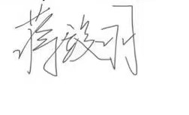
Date
2024/9/1

